How to add a Firewall, Switch to Junos space
1 Introduction 2
2 Prerequisites 2
3 Step-by-step plan firewall and switch 3
4 Step-by-step plan firewall continued 9

Introduction
This manual is intended as guide for adding a Juniper firewall or switch to Juniper Space

Prerequisites
- A user in the security group JDN_GSR_RADIUS_LOG_ON_JUNOS_SPACE_F
- Google Chrome
- Firewall/switch name and type
- Purpose of the firewall (office, ship, …)

Step-by-step plan firewall and switch
- In Google Chrome go to https://junosspace.app.jandenul.com and login with a privileged user.
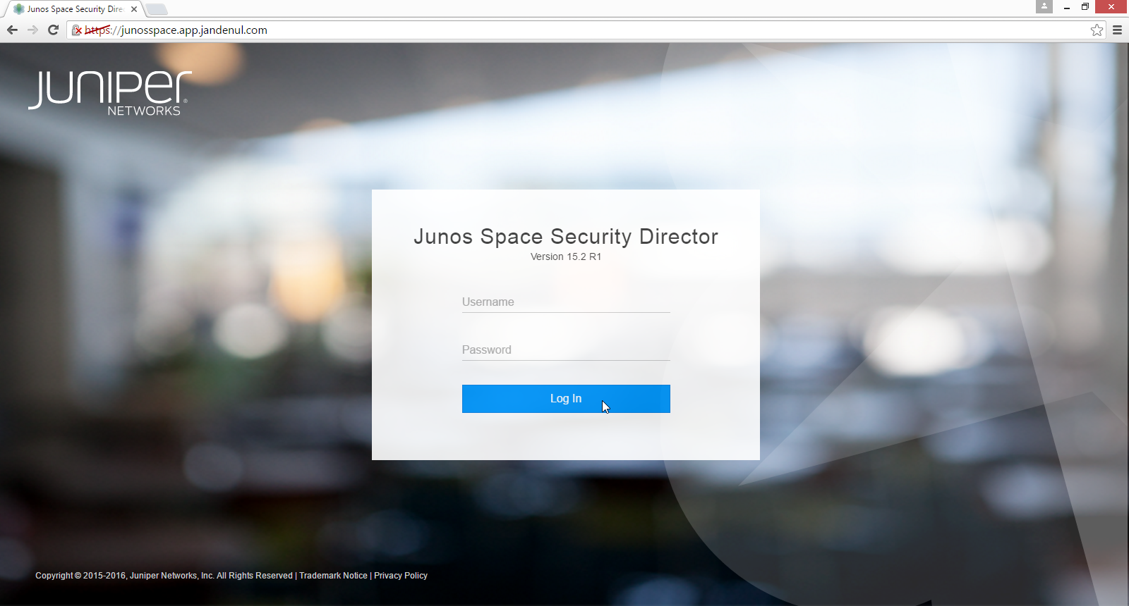
- In the top left corner click on the Junos space icon.
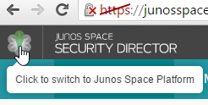
- ATTENTION: Make sure you’re working in Global domain for all next steps !
- Go to “Devices” → “Model Devices”
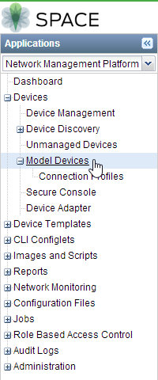
- Create a new model device by clicking the “Create Modeled Instance” button
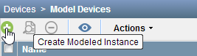
- In the new window select the correct type (firewalls: J/SRX/LN, Switches: EX)
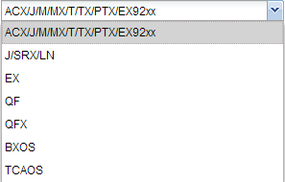
- Fill in a name
- Choose the correct platform (SRX-240H2, SRX-100H2, EX3300, EX2200, …)
- Fill in “space” as username
- Fill in the password of the space user. You can find the password in RDM .
- Choose the “default_connection_profile”
- Click “Next”
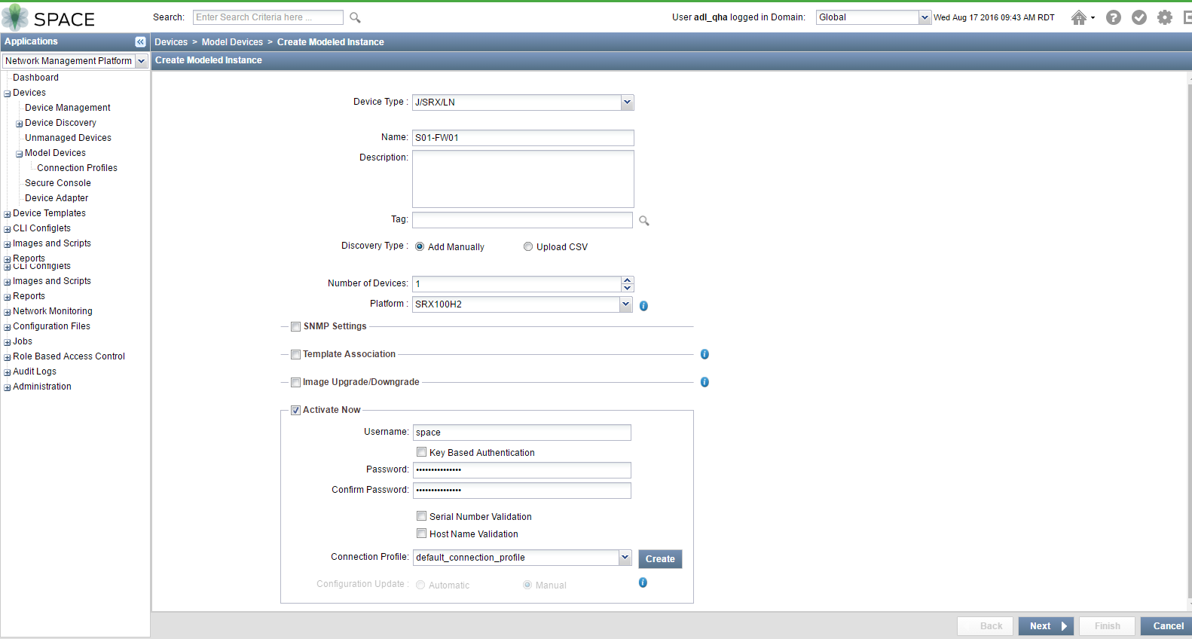

- Click “Finish”
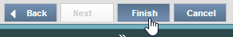
- The modeled instance is created
Click “OK”
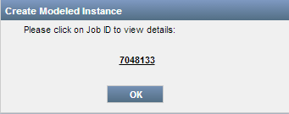
- Right click the new created instance and choose “Download configlet”
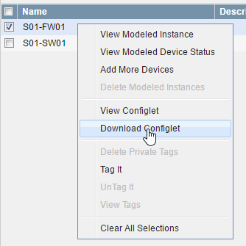
- Click “Download”
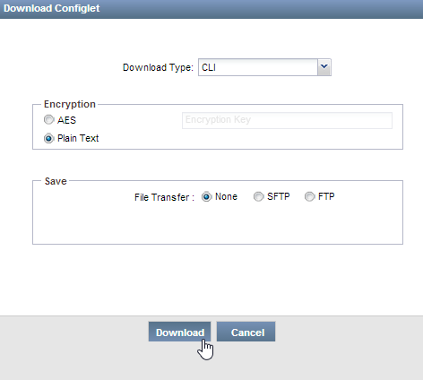
- Open the .zip file and open the juniper-config file.
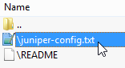
- Delete lines 4, 5, 6 and 7 from the configuration
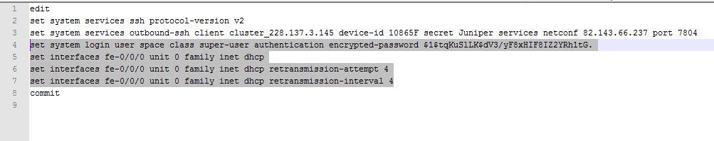
- Edit the destination port as followed:
The destination port is different on every device! Add the site id to 64000 for firewalls and 63000 for switches. On voyager the destination port for the firewall is 64001, the switch 63001. The Smallsetup01 destination ports are 64277 and 63277
- Copy the commands to the FW/SW.
- The device will apear in the Device management section:
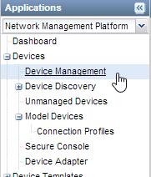

- Only for switch: assign to “Field” domain:

  - Right click device -> “Assign device to Domain”
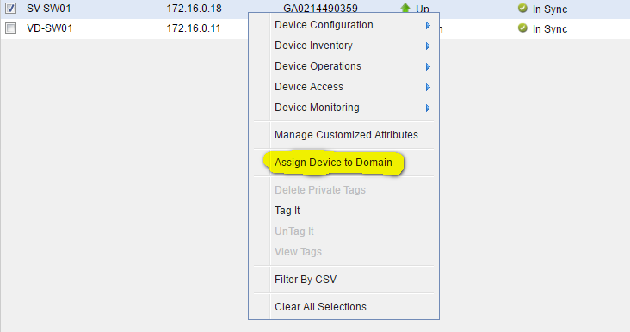

  - Click “Field” -> “Assign”
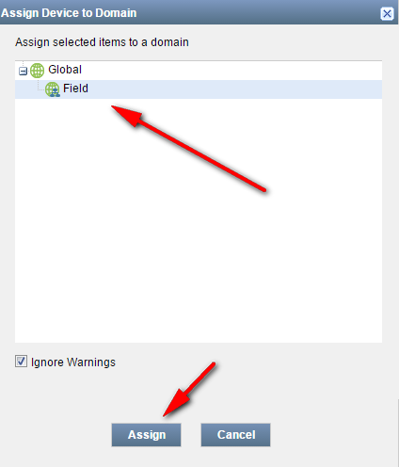

  - Click “OK”
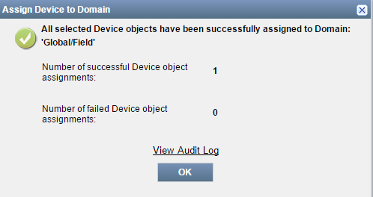

- This ends the steps for a switch.

Step-by-step plan firewall continued

- Import the security policies
In the left collumn select “Security Director” from the dropdown list.
Go to “Devices”
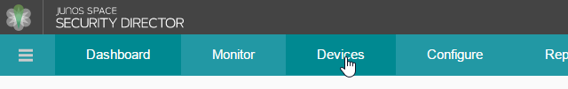
- ATTENTION: Make sure you’re working in Global domain for all next steps !

- Right click the firewall en choose “Import”
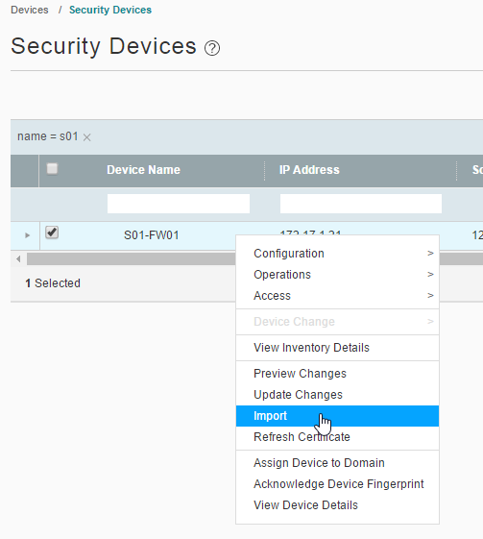

- Only import the NAT policies for Standard setups, otherwise also choose the Firewall Policies to import.
Click “Next”
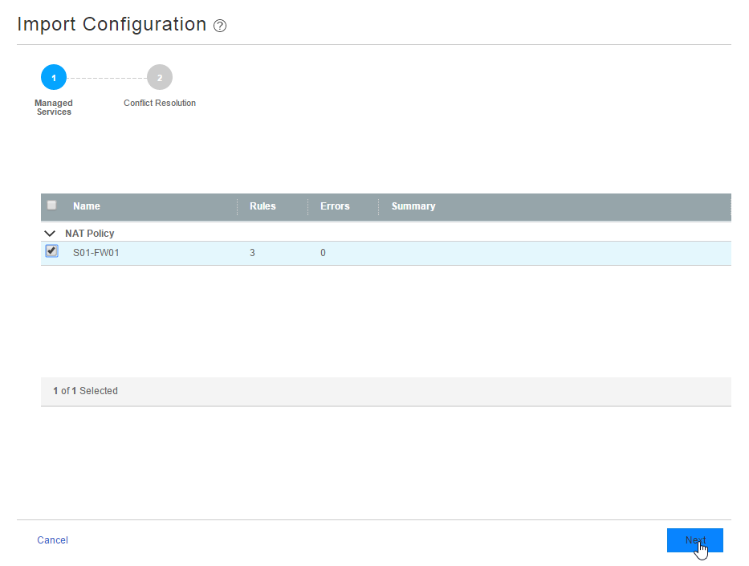

- Check for errors
Click “Finish”
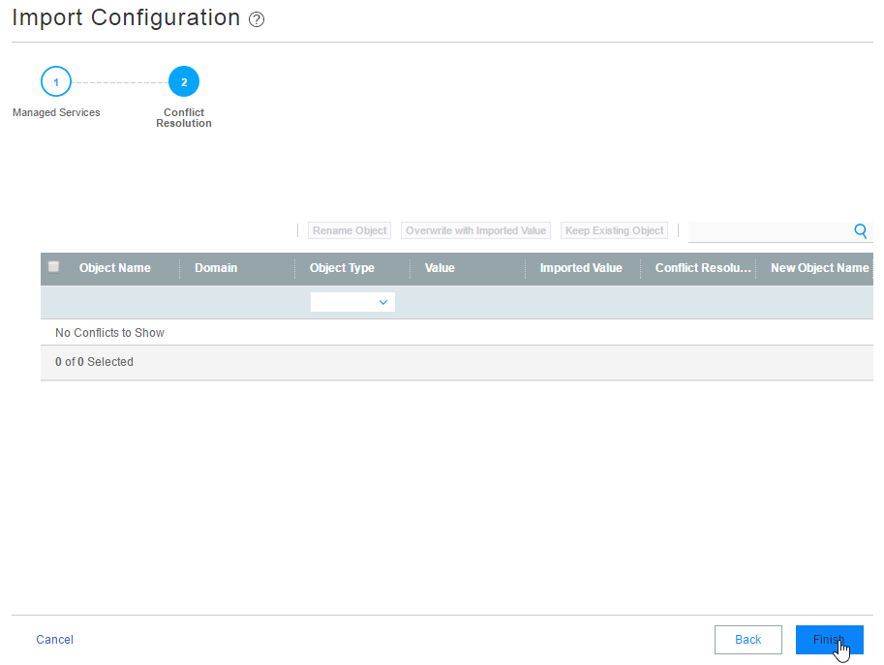

- Click “OK”
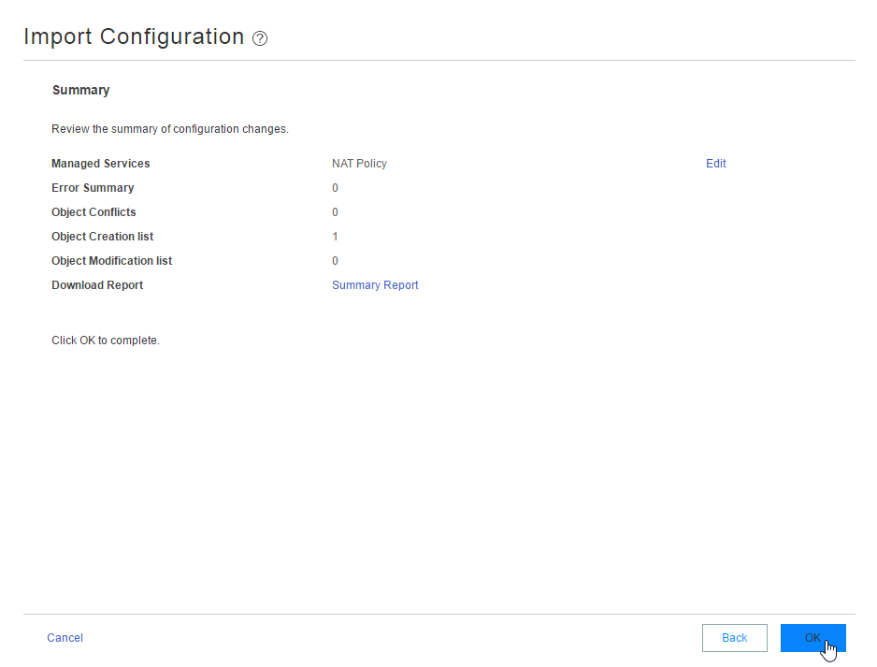

- Check for errors
Click “OK”
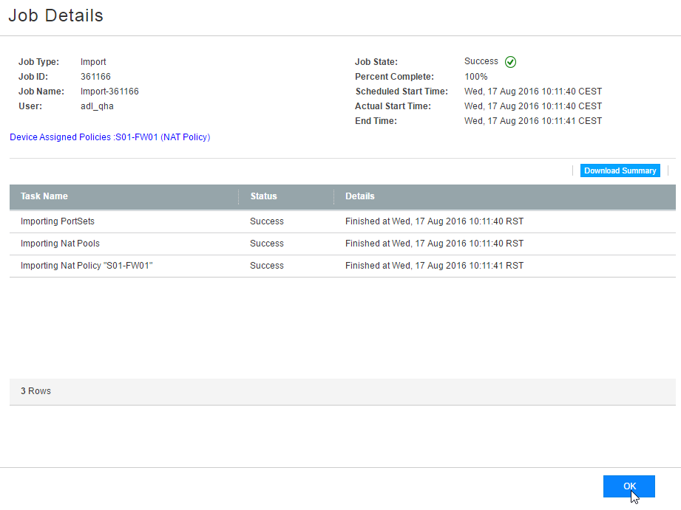

- Go to “Configure” → NAT Policy → “Policies”
Select the imported policy and click “Publish”
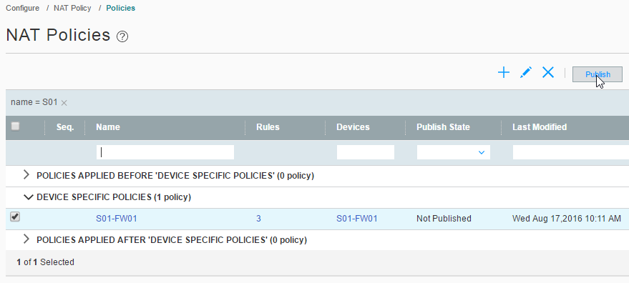

- Select the firewall
Click “Publish” to publish the NAT policy
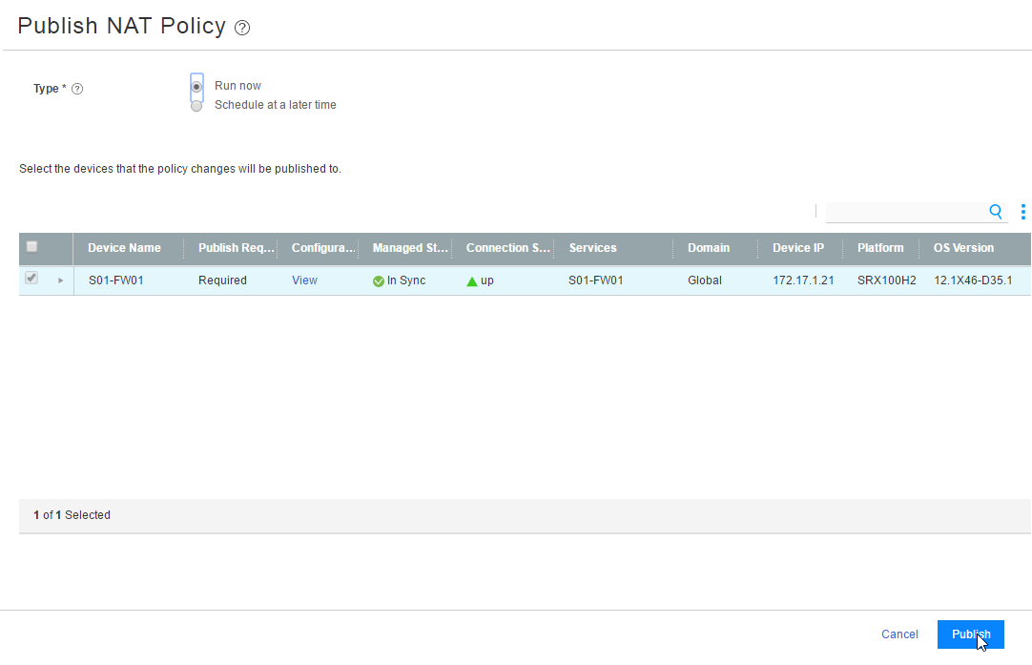

- Click OK
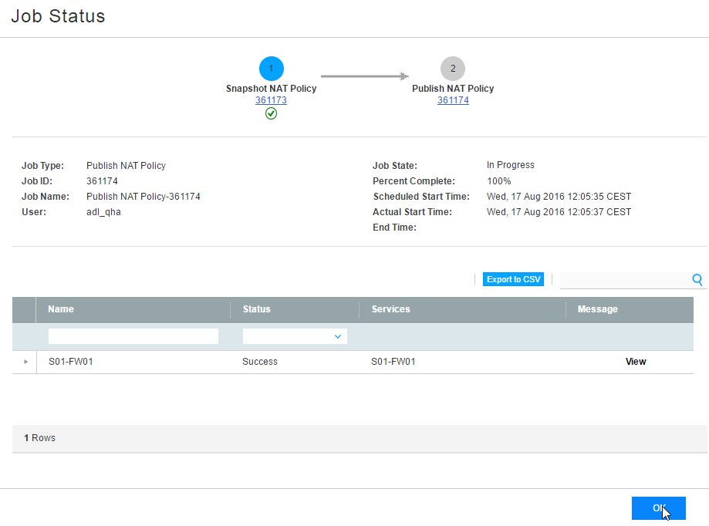

- Generate the addresses from the “Template JUNOS Switchen en Firewalls.xls” file.
Please consult “JDN Standaards - Junos - Completing xls” file for more information.
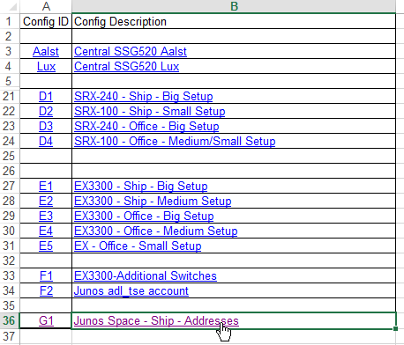

- Save the tab as a csv file.
- Go to Shared Object → Addresses → More → import from csv
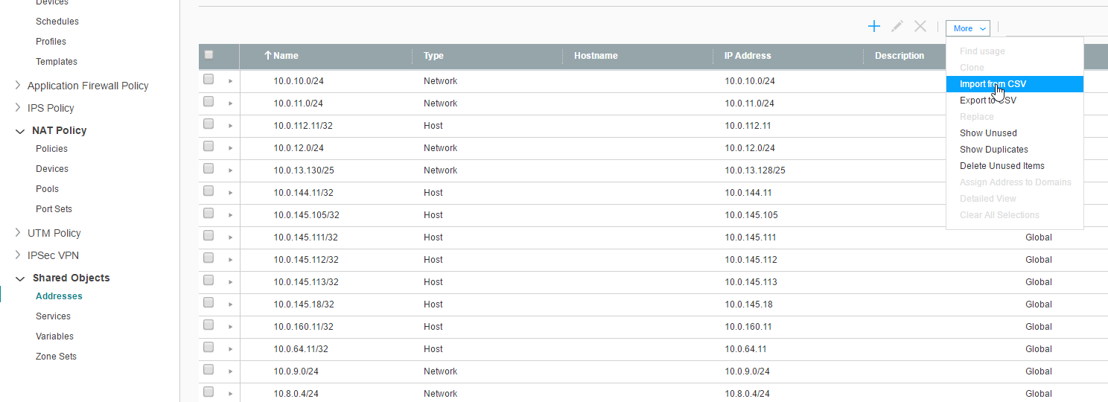

- Select the file and click “OK”
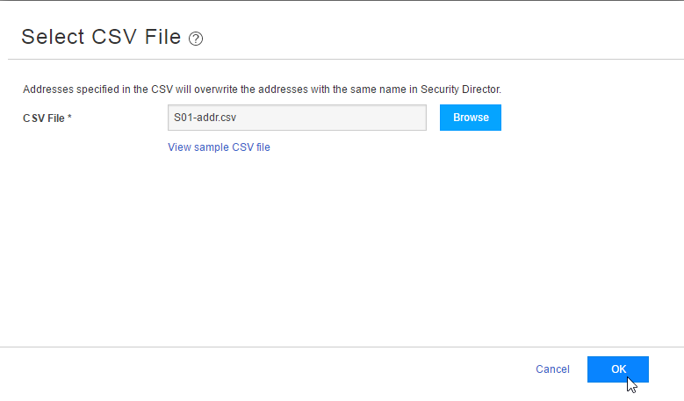

- Click “OK”
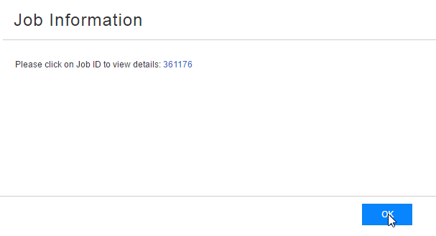

- Go to Shared Object →Variables → More → “Export to CSV”
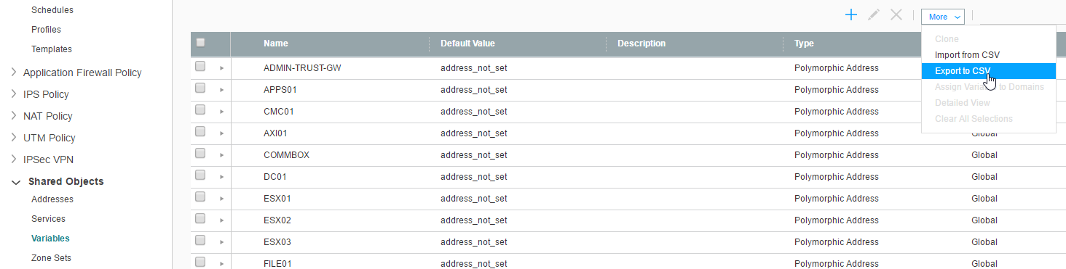

- Click “Export All”
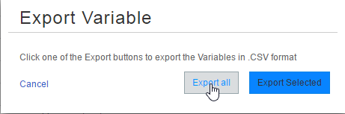

- Open the downloaded file

- Generate the variables from the “Template JUNOS Switchen en Firewalls.xls” file.
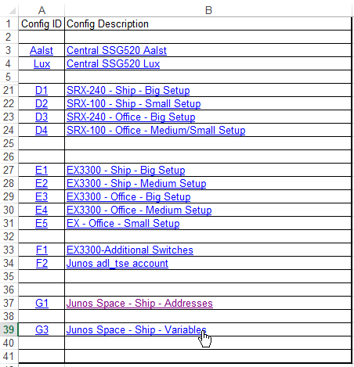

- Fill in the Firewall name as shown in Junos Space
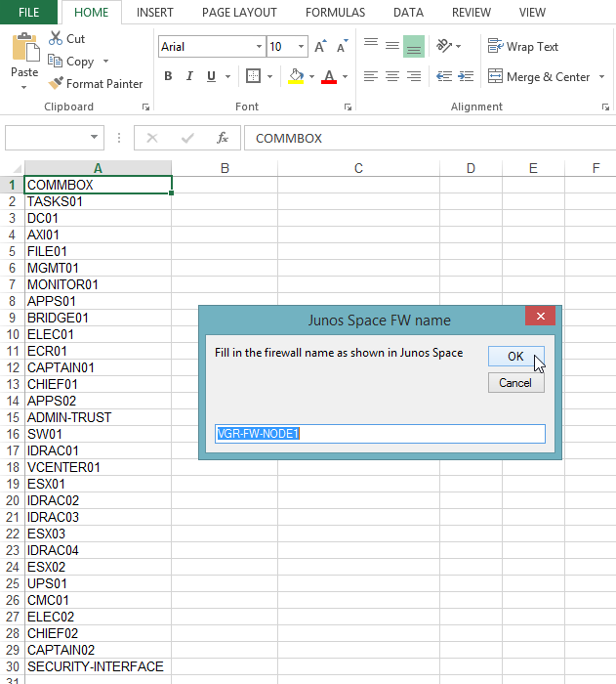

- Copy the generated lines to the opened downloaded file (export file variables). Insert the lines before “#Section End - Variable Value - Please do not modify or change this line”
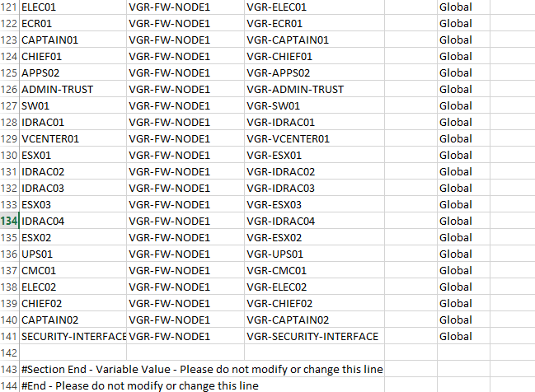

- Save the file

- Go back to Junos Space and click “OK”
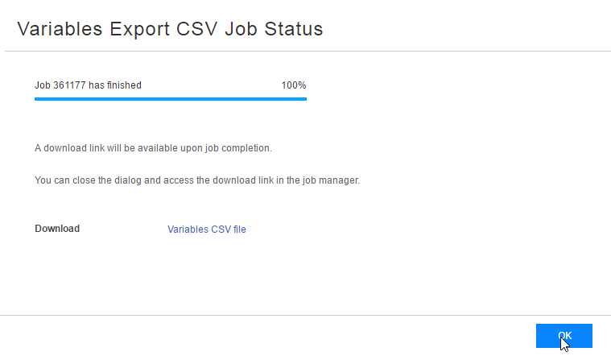

- Go to more → import from csv
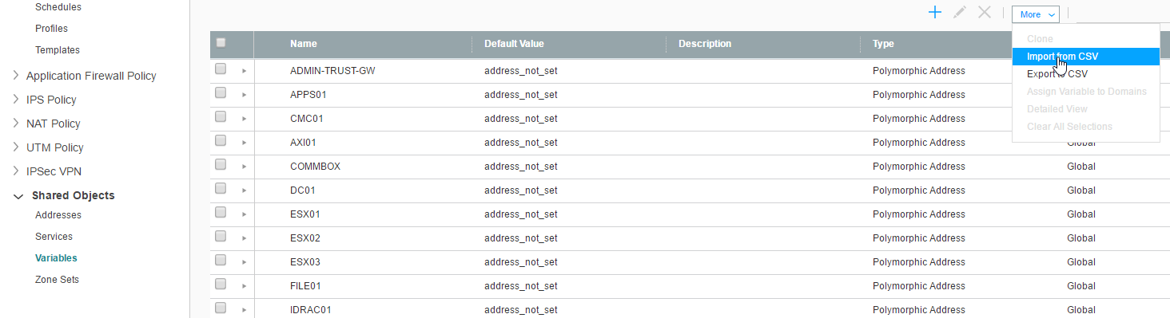

- Click “Import”
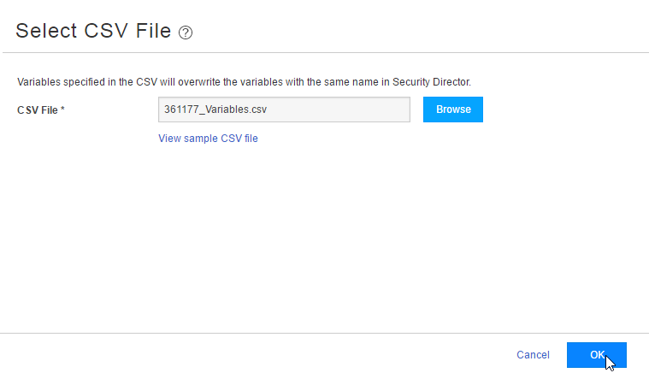

- Click “OK”
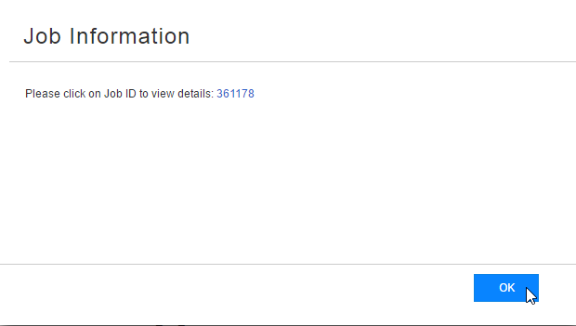
- Go to Firewall Policy → Policies
Right Click the appropriate policy and click Assign Devices
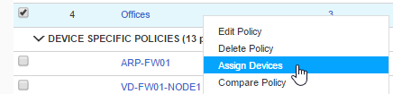

- Select the firewall and click on the arrow pointing to the right
Click on “OK”
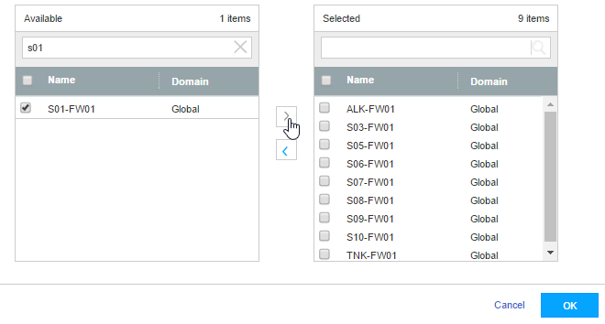

- Repeat this action for each appropriate policy.

- Select the firewall policy(ies) and click “Publish”
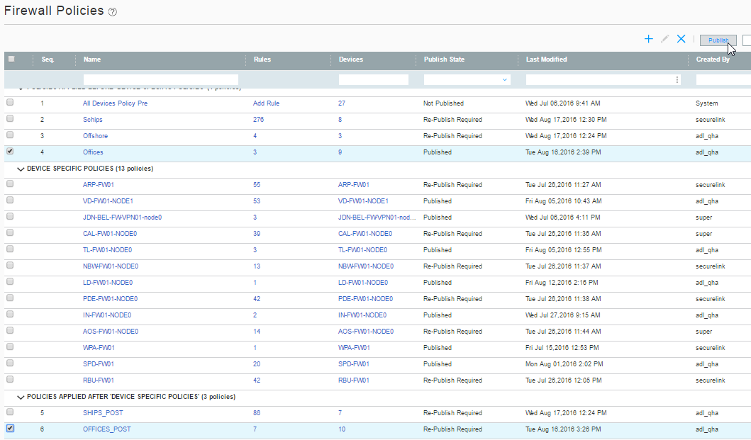

- Click “Publish”
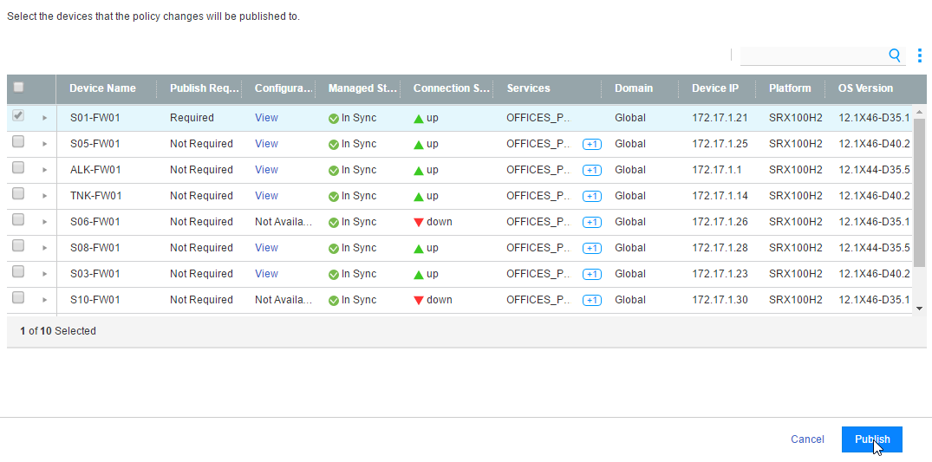

- Click “OK”
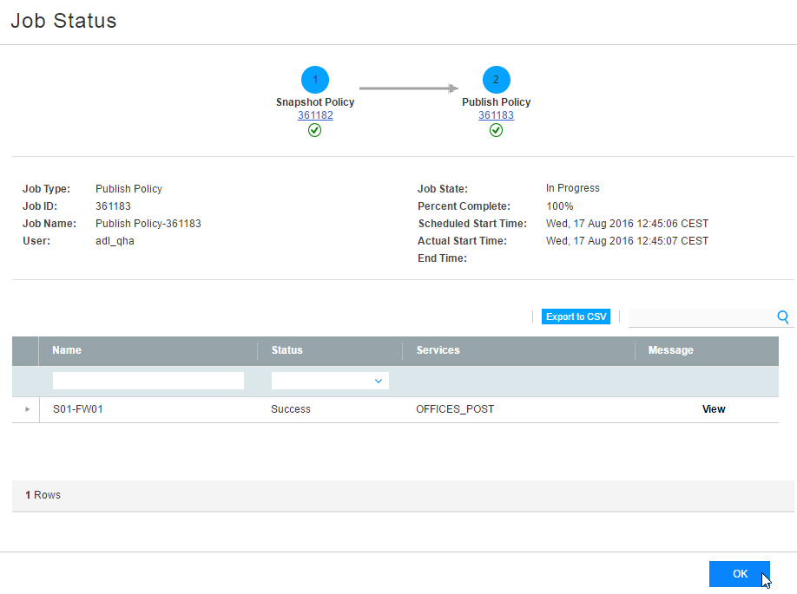

- Go to Devices → Security Devices
Select the firewall (right click) -> “Assign Device to Domain”
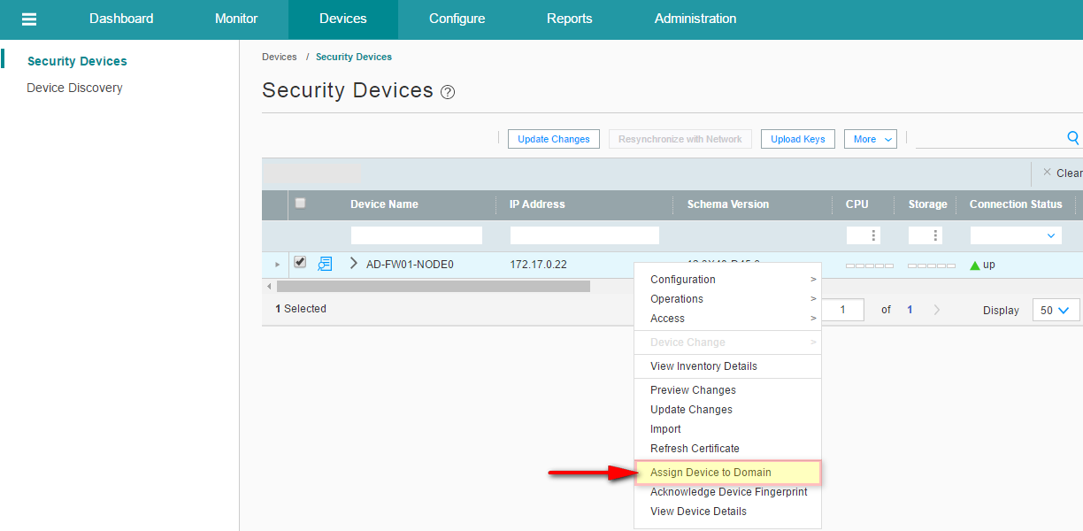

- Select “Field” and click “Assign”
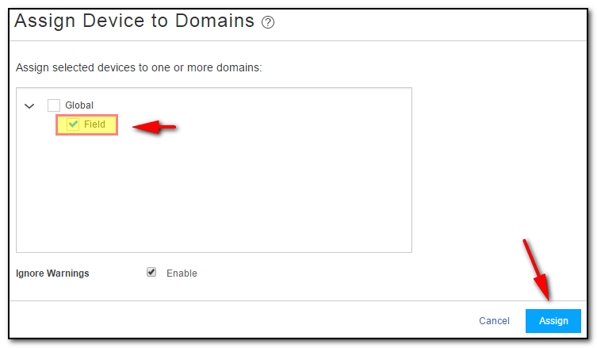

- Click OK
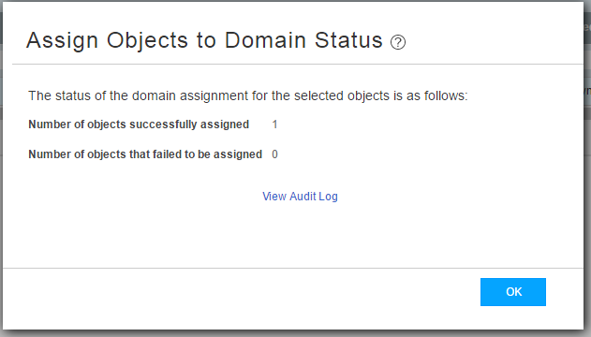

- Select the field domain
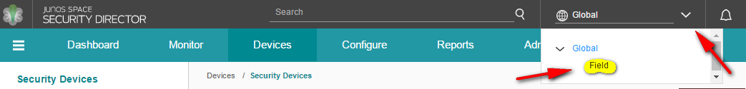

- (Re)select the firewall

- Click Update Changes
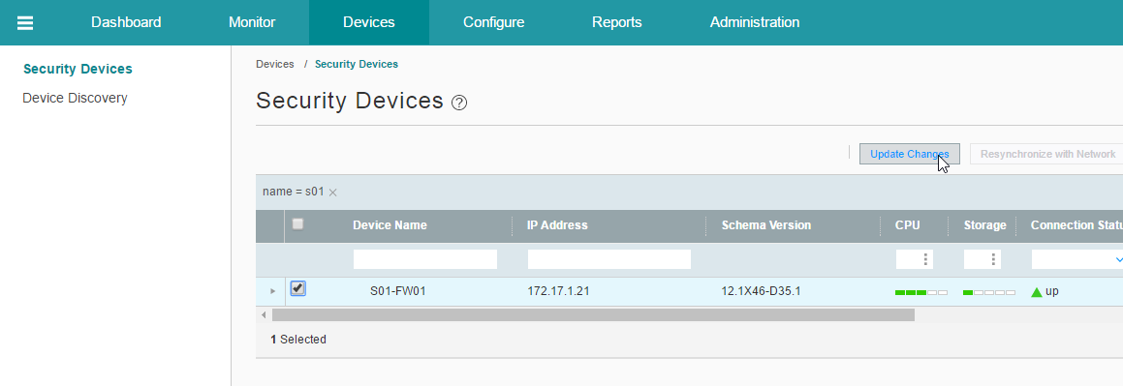

- Choose Firewall Policy and NAT
Click “Update”
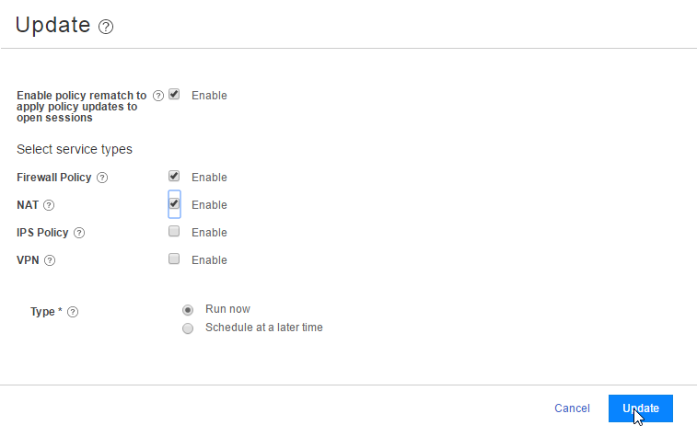

- Check for errors and click “Close”
